Lab 2: Data wrangling with dplyr — Solutions
  - F71RA Machine Learning for Risk and Insurance 1
Table of contents

Before you start
Most of the effort in any insurance modelling project goes into getting the data into shape, not into fitting the model. This lab introduces dplyr, the standard R toolkit for that job, and then uses it to explore a real motor portfolio of nearly 700,000 policies. The exploratory work you do in Part 2 is exactly what you would do before fitting the claim-frequency models later in the course.
Learning objectives. By the end of this lab you should be able to
- read and write pipelines with the pipe operator, and explain what the pipe does to the first argument of a function;
- use mutate(), select(), filter(), group_by() + summarise() and arrange(), and chain them together;
- compute exposure-weighted claim frequencies by rating factor and plot them with ggplot2;
- write small R functions, including one that takes a column name as an argument.
Packages. Install anything missing with install.packages().
library(dplyr)
Warning: package 'dplyr' was built under R version 4.2.3
library(ggplot2)
Warning: package 'ggplot2' was built under R version 4.2.3
library(readr)
Warning: package 'readr' was built under R version 4.2.3
library(scales)
Warning: package 'scales' was built under R version 4.2.3

Part 1: Introduction to dplyr

The pipe operator
We often need to chain several operations together. Suppose we want to compute
$$arctan\left(sin(exp(Γ(x)))\right) \text{at }x=1.$$
Write this as a single nested expression:
x <- 1
atan(sin(exp(gamma(x))))
[1] 0.3897659
This works, but nested calls are read inside-out and it is easy to lose count of the parentheses. In mathematics we would write the composition $arctan∘sin∘exp∘Γ$; the R equivalent is the pipe. The magrittr pipe %>% (loaded with dplyr) takes whatever is on its left and passes it as the first argument of the function on its right, so the same calculation reads left to right:
x %>% gamma() %>% exp() %>% sin() %>% atan()
[1] 0.3897659
Read %>% as “and then”: take x, and then apply gamma, and then exp, and so on. Since R 4.1 there is also a native pipe |> built into base R that does the same thing for our purposes:
x |> gamma() |> exp() |> sin() |> atan()
[1] 0.3897659
Either is fine in this course; we use %>% because it is what you will see in most existing code.
Extra arguments go inside the function call as usual. Confirm that these two lines give the same result:
v <- c(1, 2, 3, NA)
v %>% max(na.rm = TRUE)
[1] 3
max(v, na.rm = TRUE)
[1] 3
If you have met method chaining in an object-oriented language (obj.method1().method2()), the pipe plays the same role.

The tidyverse
dplyr is one of the tidyverse packages, a family of packages that share a design philosophy and work well together (ggplot2, readr and tidyr are others). dplyr is built around a handful of verbs that each take a data frame and return a data frame, which is what makes them chain together with the pipe. We look at five: mutate, select, filter, group_by/summarise and arrange.
dplyr functions return tibbles, a lightly modernised data frame that prints more sensibly (only the first ten rows, and only the columns that fit on screen). One difference from base data frames is that tibbles do not carry row names. mtcars stores the car model as row names, so:
head(mtcars, 3)
mpg cyl disp hp drat wt qsec vs am gear carb
Mazda RX4 21.0 6 160 110 3.90 2.620 16.46 0 1 4 4
Mazda RX4 Wag 21.0 6 160 110 3.90 2.875 17.02 0 1 4 4
Datsun 710 22.8 4 108 93 3.85 2.320 18.61 1 1 4 1
as_tibble(mtcars) %>% head(3)
# A tibble: 3 × 11
mpg cyl disp hp drat wt qsec vs am gear carb
<dbl> <dbl> <dbl> <dbl> <dbl> <dbl> <dbl> <dbl> <dbl> <dbl> <dbl>
1 21 6 160 110 3.9 2.62 16.5 0 1 4 4
2 21 6 160 110 3.9 2.88 17.0 0 1 4 4
3 22.8 4 108 93 3.85 2.32 18.6 1 1 4 1
Q1. What does library(dplyr, warn.conflicts = FALSE) do, and why might you want it? Use ?library.
Answer. dplyr defines functions with the same names as some base R functions, most notably filter() and lag() (from stats). When a package masks an existing function, library() prints a “The following objects are masked” message. warn.conflicts = FALSE suppresses that message; it is cosmetic and does not change which function is used. It is common in rendered documents to keep the output clean, but when writing code interactively the warning is useful: it is telling you that filter() now means dplyr::filter().

mutate: add or change columns
The pattern is mutate(data, new_column = f(existing_columns)), where f must return a vector of the same length as the data (or length 1, which is recycled). If new_column already exists it is overwritten.
To keep the car names when converting mtcars to a tibble, put them in a column:
mtcars %>% mutate(model = rownames(mtcars)) %>% head(3)
mpg cyl disp hp drat wt qsec vs am gear carb model
Mazda RX4 21.0 6 160 110 3.90 2.620 16.46 0 1 4 4 Mazda RX4
Mazda RX4 Wag 21.0 6 160 110 3.90 2.875 17.02 0 1 4 4 Mazda RX4 Wag
Datsun 710 22.8 4 108 93 3.85 2.320 18.61 1 1 4 1 Datsun 710
Q2. Replace = with <- in the line above and run it. What happens to the column name, and why?
mtcars %>% mutate(model <- rownames(mtcars)) %>% head(2) %>% names()
[1] "mpg" "cyl"
[3] "disp" "hp"
[5] "drat" "wt"
[7] "qsec" "vs"
[9] "am" "gear"
[11] "carb" "model <- rownames(mtcars)"
Answer. The new column is called model <- rownames(mtcars), the literal text of the expression. Inside a function call, = means “this argument is named model”, whereas <- is just an assignment expression whose value is passed as an unnamed argument. mutate has no name for the column, so it uses the deparsed code as the name. This is a common source of confusion: use = for named arguments, <- for assignment.
Suppose you suspect mpg depends on the square root of disp. Create that column and keep only mpg, disp and the new column for display:
mtcars %>% mutate(root_disp = sqrt(disp)) %>% select(mpg, disp, root_disp) %>% head(3)
mpg disp root_disp
Mazda RX4 21.0 160 12.64911
Mazda RX4 Wag 21.0 160 12.64911
Datsun 710 22.8 108 10.39230
mutate can create several columns at once, and later ones can use earlier ones:
mtcars %>%
mutate(kpl = mpg * 0.425, # miles per gallon to km per litre
kpl_rounded = round(kpl)) %>%
select(mpg, kpl, kpl_rounded) %>% head(3)
mpg kpl kpl_rounded
Mazda RX4 21.0 8.925 9
Mazda RX4 Wag 21.0 8.925 9
Datsun 710 22.8 9.690 10

select: choose columns
Insurance data sets routinely have dozens of columns, most irrelevant to a given question. select keeps only the ones you name:
mtcars %>% select(cyl, disp, hp) %>% head(2)
cyl disp hp
Mazda RX4 6 160 110
Mazda RX4 Wag 6 160 110
To drop columns, negate them. Any of the following drops both cyl and am:
mtcars %>% select(-cyl, -am) %>% names()
[1] "mpg" "disp" "hp" "drat" "wt" "qsec" "vs" "gear" "carb"
mtcars %>% select(!c(cyl, am)) %>% names()
[1] "mpg" "disp" "hp" "drat" "wt" "qsec" "vs" "gear" "carb"
mtcars %>% select(-c(cyl, am)) %>% names()
[1] "mpg" "disp" "hp" "drat" "wt" "qsec" "vs" "gear" "carb"
Q3. What does mtcars %>% select(!cyl, !am) return, and why is it not what you might expect?
mtcars %>% select(!cyl, !am) %>% names()
[1] "mpg" "disp" "hp" "drat" "wt" "qsec" "vs" "am" "gear" "carb"
[11] "cyl"
Answer. It returns every column. select takes the union of the selections listed as separate arguments: “everything except cyl” together with “everything except am” is everything. To exclude both you need a single expression, !c(cyl, am), or the - form which is treated as a sequence of removals. Watch out for this one.
You can also select by pattern. starts_with(), ends_with(), contains() and matches() (regular expressions) are all available; see ?tidyselect::select_helpers.
iris %>% select(starts_with("Sepal")) %>% head(2)
Sepal.Length Sepal.Width
1 5.1 3.5
2 4.9 3.0

filter: choose rows
filter keeps the rows for which a logical condition is TRUE:
mtcars %>% filter(cyl == 6) %>% nrow()
[1] 7
Multiple conditions can be combined with &, | and !. Because “and” is so common, listing conditions separated by commas is equivalent to joining them with &:
mtcars %>% filter(cyl == 6 & mpg > 20)
mpg cyl disp hp drat wt qsec vs am gear carb
Mazda RX4 21.0 6 160 110 3.90 2.620 16.46 0 1 4 4
Mazda RX4 Wag 21.0 6 160 110 3.90 2.875 17.02 0 1 4 4
Hornet 4 Drive 21.4 6 258 110 3.08 3.215 19.44 1 0 3 1
mtcars %>% filter(cyl == 6, mpg > 20)
mpg cyl disp hp drat wt qsec vs am gear carb
Mazda RX4 21.0 6 160 110 3.90 2.620 16.46 0 1 4 4
Mazda RX4 Wag 21.0 6 160 110 3.90 2.875 17.02 0 1 4 4
Hornet 4 Drive 21.4 6 258 110 3.08 3.215 19.44 1 0 3 1
Q4. Write a filter that keeps cars with either 4 cylinders or more than 25 mpg. How many are there?
mtcars %>% filter(cyl == 4 | mpg > 25) %>% nrow()
[1] 11
Answer. 11 cars. Every car with more than 25 mpg is a 4-cylinder car, so this is the same as filter(cyl == 4).

group_by and summarise: statistics by group
This is the most important pair of verbs for insurance work, where almost every question is “what is the average of X within each level of Y?”.
Q5. What does :: mean, as in dplyr::filter?
Answer. pkg::fun calls the function fun from package pkg without attaching the package with library(), and makes it unambiguous which package’s version you mean. It is useful when two loaded packages define the same name, e.g. dplyr::filter versus stats::filter.
The iris data has 50 flowers from each of three species. To find the mean sepal length by species we partition the data by Species and compute the mean within each part:
iris %>% group_by(Species) %>% summarise(mean_length = mean(Sepal.Length))
# A tibble: 3 × 2
Species mean_length
<fct> <dbl>
1 setosa 5.01
2 versicolor 5.94
3 virginica 6.59
summarise can compute several statistics at once. n() counts the rows in each group:
iris %>% group_by(Species) %>%
summarise(n = n(), mean_length = mean(Sepal.Length), max_length = max(Sepal.Length))
# A tibble: 3 × 4
Species n mean_length max_length
<fct> <int> <dbl> <dbl>
1 setosa 50 5.01 5.8
2 versicolor 50 5.94 7
3 virginica 50 6.59 7.9
Grouping works on numeric columns too, treating each distinct value as a category:
mtcars %>% group_by(cyl) %>% summarise(n = n(), mean_disp = mean(disp))
# A tibble: 3 × 3
cyl n mean_disp
<dbl> <int> <dbl>
1 4 11 105.
2 6 7 183.
3 8 14 353.
You can group by more than one column for a finer partition. Here, within each number of cylinders, we separate automatic (am == 0) and manual (am == 1) cars:
mtcars %>% group_by(cyl, am) %>% summarise(n = n(), mean_disp = mean(disp))
`summarise()` has grouped output by 'cyl'. You can override using the `.groups`
argument.
# A tibble: 6 × 4
# Groups: cyl [3]
cyl am n mean_disp
<dbl> <dbl> <int> <dbl>
1 4 0 3 136.
2 4 1 8 93.6
3 6 0 4 205.
4 6 1 3 155
5 8 0 12 358.
6 8 1 2 326
Q6. R prints a message: summarise() has grouped output by 'cyl'. You can override using the .groups argument. What does this mean, and what does adding .groups = "drop" change? Check with group_vars().
by_cyl_am <- mtcars %>% group_by(cyl, am) %>% summarise(mean_disp = mean(disp))
`summarise()` has grouped output by 'cyl'. You can override using the `.groups`
argument.
group_vars(by_cyl_am)
[1] "cyl"
by_cyl_am_dropped <- mtcars %>% group_by(cyl, am) %>%
summarise(mean_disp = mean(disp), .groups = "drop")
group_vars(by_cyl_am_dropped)
character(0)
Answer. When you summarise a data frame grouped by several columns, summarise uses up the last grouping variable and the result stays grouped by the remaining ones (here cyl). That matters because any further mutate or summarise on the result would then operate within each cyl group, which is easy to forget. .groups = "drop" returns an ordinary ungrouped tibble. It is good practice to set .groups explicitly, or to call ungroup() when you are done, so that later steps behave the way you expect.

arrange: sort rows
mtcars %>% arrange(mpg) %>% head(3) # increasing
mpg cyl disp hp drat wt qsec vs am gear carb
Cadillac Fleetwood 10.4 8 472 205 2.93 5.250 17.98 0 0 3 4
Lincoln Continental 10.4 8 460 215 3.00 5.424 17.82 0 0 3 4
Camaro Z28 13.3 8 350 245 3.73 3.840 15.41 0 0 3 4
mtcars %>% arrange(desc(mpg)) %>% head(3) # decreasing
mpg cyl disp hp drat wt qsec vs am gear carb
Toyota Corolla 33.9 4 71.1 65 4.22 1.835 19.90 1 1 4 1
Fiat 128 32.4 4 78.7 66 4.08 2.200 19.47 1 1 4 1
Honda Civic 30.4 4 75.7 52 4.93 1.615 18.52 1 1 4 2
mtcars %>% arrange(cyl, desc(mpg)) %>% head(3) # by cyl, then mpg within cyl
mpg cyl disp hp drat wt qsec vs am gear carb
Toyota Corolla 33.9 4 71.1 65 4.22 1.835 19.90 1 1 4 1
Fiat 128 32.4 4 78.7 66 4.08 2.200 19.47 1 1 4 1
Honda Civic 30.4 4 75.7 52 4.93 1.615 18.52 1 1 4 2
Q7. Using the verbs above, find the mean mpg for each combination of cyl and gear, and list the combinations from most to least fuel-efficient.
mtcars %>% group_by(cyl, gear) %>%
summarise(n = n(), mean_mpg = mean(mpg), .groups = "drop") %>%
arrange(desc(mean_mpg))
# A tibble: 8 × 4
cyl gear n mean_mpg
<dbl> <dbl> <int> <dbl>
1 4 5 2 28.2
2 4 4 8 26.9
3 4 3 1 21.5
4 6 3 2 19.8
5 6 4 4 19.8
6 6 5 1 19.7
7 8 5 2 15.4
8 8 3 12 15.0

Lexical scoping and non-standard evaluation (optional)
This section is optional but explains a behaviour that will eventually bite you.
Inside mutate, column names are treated as variables. If a name is not a column, R looks outside the data frame for it:
external <- 1:32
mtcars %>% select(mpg, cyl) %>% mutate(out1 = cyl^2, out2 = external^2) %>% head(3)
mpg cyl out1 out2
Mazda RX4 21.0 6 36 1
Mazda RX4 Wag 21.0 6 36 4
Datsun 710 22.8 4 16 9
This lookup rule is called lexical scoping. It is convenient, but it means that if you also have a variable cyl in your workspace, mutate will silently use the column and ignore your variable. If you do need the outside variable, write .env$cyl; if you need to make clear you mean the column, write .data$cyl.
Relatedly, some R functions read the code you type rather than its value. This is called non-standard evaluation (NSE). library() is the classic example: both of these work,
library(dplyr)
library("dplyr")
because library captures the unquoted name and converts it to the string "dplyr". So what does this do?
dplyr <- "ggplot2"
library(dplyr)
Answer. It loads dplyr, not ggplot2. library uses NSE by default: it takes the symbol dplyr and turns it into the string "dplyr" without ever evaluating the variable. To use the variable’s value you would need library(dplyr, character.only = TRUE). dplyr and ggplot2 use NSE everywhere, which is why you can write select(cyl) without quotes; it is also why, when something behaves oddly, a scoping or NSE issue is a good first suspect.

Part 2: Case study — French motor third-party liability
freMTPL2freq records one year of experience for 678,013 French motor third-party liability policies. Each row is a policy; the variables are
Variable | Description
IDpol | Policy identifier
ClaimNb | Number of claims during the exposure period (the response)
Exposure | Length of the exposure period, in years
Area | Area code, A (rural) to F (urban centre)
VehPower | Power of the car (ordered categories 4–15)
VehAge | Age of the vehicle, years
DrivAge | Age of the driver, years
BonusMalus | Bonus/malus level, 50–350. Below 100 is a bonus (no-claims discount), above 100 a malus
VehBrand | Car brand (unordered categories B1–B14)
VehGas | Fuel type, Diesel or Regular
Density | Population density of the driver’s home town, inhabitants per km²
Region | French region
Download freMTPL2freq.csv from the course GitHub page and save it in the same folder as this notebook. Read it in with readr::read_csv() (type ?read_csv for the documentation):
dat <- read_csv("freMTPL2freq.csv")
Take a first look with glimpse(), the dplyr equivalent of str():
glimpse(dat)
Rows: 678,013
Columns: 12
$ IDpol <dbl> 1, 3, 5, 10, 11, 13, 15, 17, 18, 21, 25, 27, 30, 32, 35, 36…
$ ClaimNb <dbl> 1, 1, 1, 1, 1, 1, 1, 1, 1, 1, 1, 1, 1, 1, 1, 1, 1, 1, 1, 1,…
$ Exposure <dbl> 0.10, 0.77, 0.75, 0.09, 0.84, 0.52, 0.45, 0.27, 0.71, 0.15,…
$ Area <chr> "D", "D", "B", "B", "B", "E", "E", "C", "C", "B", "B", "C",…
$ VehPower <dbl> 5, 5, 6, 7, 7, 6, 6, 7, 7, 7, 7, 7, 4, 4, 4, 9, 6, 6, 6, 6,…
$ VehAge <dbl> 0, 0, 2, 0, 0, 2, 2, 0, 0, 0, 0, 0, 1, 0, 9, 0, 2, 2, 2, 2,…
$ DrivAge <dbl> 55, 55, 52, 46, 46, 38, 38, 33, 33, 41, 41, 56, 27, 27, 23,…
$ BonusMalus <dbl> 50, 50, 50, 50, 50, 50, 50, 68, 68, 50, 50, 50, 90, 90, 100…
$ VehBrand <chr> "B12", "B12", "B12", "B12", "B12", "B12", "B12", "B12", "B1…
$ VehGas <chr> "Regular", "Regular", "Diesel", "Diesel", "Diesel", "Regula…
$ Density <dbl> 1217, 1217, 54, 76, 76, 3003, 3003, 137, 137, 60, 60, 173, …
$ Region <chr> "R82", "R82", "R22", "R72", "R72", "R31", "R31", "R91", "R9…

Task 1: Factors
VehGas, VehBrand, Area and Region are stored as character columns. For modelling they need to be factors: a vector of integer codes plus a set of labels, so that R knows the values are categories rather than free text. Use mutate with factor() to convert VehGas, and then across() to convert all four in one call. Check the result with levels().
dat <- dat %>% mutate(VehGas = factor(VehGas))
levels(dat$VehGas)
[1] "Diesel" "Regular"
dat <- dat %>% mutate(across(c(VehBrand, Area, Region), factor))
sapply(dat[c("VehGas", "VehBrand", "Area", "Region")], nlevels)
VehGas VehBrand Area Region
2 11 6 22
Answer. factor() sorts the distinct values alphabetically and uses that order for the levels, so Diesel is the reference level. across(cols, f) applies f to each of the named columns inside a single mutate. Note that VehBrand levels sort as text, so B10 comes before B2; this is harmless for modelling but worth knowing when you read output.

Task 2: Capping
A few policies report an implausibly large number of claims, and some have Exposure above one year. These may be bulk or fleet policies. A crude fix, used in the published analyses of this data, is to cap ClaimNb at 4 and Exposure at 1. Before capping, count how many rows each cap will affect. Hint: pmin().
dat %>% summarise(n_claims_over_4 = sum(ClaimNb > 4),
n_exposure_over_1 = sum(Exposure > 1),
max_claims = max(ClaimNb), max_exposure = max(Exposure))
# A tibble: 1 × 4
n_claims_over_4 n_exposure_over_1 max_claims max_exposure
<int> <int> <dbl> <dbl>
1 9 1224 16 2.01
dat <- dat %>% mutate(ClaimNb = pmin(ClaimNb, 4),
Exposure = pmin(Exposure, 1))
Answer. pmin(x, 4) is the parallel minimum: it compares each element of x with 4 and returns the smaller, so it caps the vector at 4. min(x, 4) would return a single number. Only 9 policies have more than four claims (the maximum is 16) and 1,224 have exposure above one year (maximum 2.01), so out of 678,013 rows the caps change very little of the data while removing the most implausible values.

Task 3: Log exposure
Create a column log_exposure. Why might we want this? Hint: think about how a Poisson regression for claim counts should depend on exposure.
dat <- dat %>% mutate(log_exposure = log(Exposure))
summary(dat$log_exposure)
Min. 1st Qu. Median Mean 3rd Qu. Max.
-5.90263 -1.71480 -0.71335 -1.07814 -0.01005 0.00000
Answer. In a Poisson regression for claim counts we model the expected number of claims as $E[N]=\text{Exposure}×λ(x)$, where $λ(x)$ is the annual claim frequency for a policy with covariates $x$. With a log link, $logE[N]=log(\text{Exposure})+logλ(x)$, so $log(\text{Exposure})$ enters the model as an offset: a term with coefficient fixed at 1. Every exposure is positive so the log is always defined. We will use this column when we fit GLMs later in the course.

Task 4: Recoding Area
Create a numeric column Area_num with A = 1, B = 2, and so on. Do it two ways: by writing a small function and using it inside mutate, and by using as.integer() on the factor. Confirm they agree.
area_to_num <- function(a) match(as.character(a), LETTERS)
dat <- dat %>% mutate(Area_num = area_to_num(Area),
Area_num2 = as.integer(Area))
all(dat$Area_num == dat$Area_num2)
[1] TRUE
dat %>% count(Area, Area_num)
# A tibble: 6 × 3
Area Area_num n
<fct> <int> <int>
1 A 1 103957
2 B 2 75459
3 C 3 191880
4 D 4 151596
5 E 5 137167
6 F 6 17954
dat <- dat %>% select(-Area_num2)
Answer. match(x, LETTERS) returns the position of each element of x in the vector LETTERS, so "A" gives 1, "B" gives 2. as.integer() on a factor returns the underlying level codes, which agree here only because the levels are in alphabetical order A–F. Treating Area as a number makes sense because the codes are ordered by urban density, but doing so assumes the step from A to B has the same effect as from E to F, which a factor does not assume.

Task 5: The distribution of claim counts
Draw a bar chart of ClaimNb with ggplot2. The y-axis labels will appear as 0e+00, 2e+05 and so on; fix them so that they read 0, 200,000, … Hint: scales::label_comma(), or ?scale_y_continuous. Then compute the proportion of policies with no claims and check it against the 94.98% quoted for this data set.
ggplot(dat, aes(x = factor(ClaimNb))) +
geom_bar(fill = "steelblue") +
scale_y_continuous(labels = label_comma()) +
labs(x = "Number of claims", y = "Number of policies") +
theme_minimal()
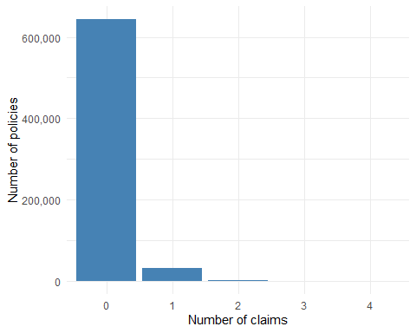
dat %>% summarise(prop_zero = mean(ClaimNb == 0))
# A tibble: 1 × 1
prop_zero
<dbl>
1 0.950
dat %>% count(ClaimNb) %>% mutate(prop = n / sum(n))
# A tibble: 5 × 3
ClaimNb n prop
<dbl> <int> <dbl>
1 0 643953 0.950
2 1 32178 0.0475
3 2 1784 0.00263
4 3 82 0.000121
5 4 16 0.0000236
Answer. R switches to scientific notation for large axis values. scale_y_continuous(labels = label_comma()) formats the labels with thousands separators; alternatives are labels = label_number() or setting options(scipen = 999) globally. 643,953 of 678,013 policies (94.98%) have no claims, matching the quoted figure; 4.75% have exactly one, 0.26% have two and only 98 policies have three or four. This very heavy concentration at zero is typical of motor frequency data and is one reason the Poisson distribution, and its overdispersed cousins, are the standard starting point.

Task 6: Empirical claim frequency by rating factor
For pricing, the quantity of interest is not the raw count but the claim frequency per unit of exposure. The overall empirical frequency is
λ=i​ClaimNbii​Exposurei,
and the same formula within each level of a rating factor tells us how risky that level is.
(a) Compute the overall frequency, then the frequency by Area using group_by and summarise. Also record the total exposure in each group, since a frequency based on little exposure is unreliable.
dat %>% summarise(claims = sum(ClaimNb), exposure = sum(Exposure),
frequency = claims / exposure)
# A tibble: 1 × 3
claims exposure frequency
<dbl> <dbl> <dbl>
1 36056 358360. 0.101
dat %>% group_by(Area) %>%
summarise(exposure = sum(Exposure), frequency = sum(ClaimNb) / sum(Exposure))
# A tibble: 6 × 3
Area exposure frequency
<fct> <dbl> <dbl>
1 A 61957. 0.0816
2 B 43002. 0.0884
3 C 104403. 0.0946
4 D 77088. 0.109
5 E 63786. 0.122
6 F 8125. 0.139
(b) You are about to do the same thing for every rating factor, so write a function freq_by(data, var) that returns the table for any column. Inside a dplyr verb, a column name passed as a function argument must be wrapped in double braces, { var }, so that dplyr knows to look for a column rather than a variable. Test it on VehGas.
freq_by <- function(data, var) {
data %>%
group_by({{ var }}) %>%
summarise(n = n(), exposure = sum(Exposure),
frequency = sum(ClaimNb) / sum(Exposure), .groups = "drop")
}
freq_by(dat, VehGas)
# A tibble: 2 × 4
VehGas n exposure frequency
<fct> <int> <dbl> <dbl>
1 Diesel 332136 170588. 0.0975
2 Regular 345877 187773. 0.103
freq_by(dat, VehPower)
# A tibble: 12 × 4
VehPower n exposure frequency
<dbl> <int> <dbl> <dbl>
1 4 115349 60055. 0.0943
2 5 124821 68148. 0.107
3 6 148976 82498. 0.102
4 7 145401 77920. 0.0979
5 8 46956 22674. 0.0848
6 9 30085 15339. 0.114
7 10 31354 15367. 0.116
8 11 18352 8491. 0.106
9 12 8214 3791. 0.0947
10 13 3229 1637. 0.0935
11 14 2350 1180. 0.101
12 15 2926 1260. 0.0984
Answer. Without { }, group_by(var) would look for a column literally called var and fail. The double braces (“embracing”) tell dplyr to substitute the column name the caller supplied. The overall frequency is 36,056 claims over 358,360 exposure-years, about 0.101 claims per year. By area it rises steadily from 0.082 in A (rural) to 0.139 in F (urban centre). Diesel cars (0.098) are slightly less claim-prone than petrol cars (0.103), a small difference. Vehicle power shows no clean trend: frequency dips at power 8 and peaks at 9–10, and the top categories (13–15) have under 2,000 exposure-years each, so their values are noisy.
(c) DrivAge, VehAge, BonusMalus and Density are continuous, so grouping by their raw values gives too many tiny groups. Use cut() inside mutate to band them. Suggested bands: driver age at 18, 21, 26, 31, 41, 51, 71, 100; vehicle age at 0, 1, 2, 5, 10, 100; bonus–malus at 50, 60, 80, 100, 150, 350; density on the log scale, cut(log(Density), 8). Then use freq_by() on each banded column.
dat <- dat %>% mutate(
DrivAge_band = cut(DrivAge, c(18, 21, 26, 31, 41, 51, 71, 101), right = FALSE),
VehAge_band = cut(VehAge, c(0, 1, 2, 5, 10, 101), right = FALSE),
BonusMalus_band = cut(BonusMalus, c(50, 60, 80, 100, 150, 351), right = FALSE),
Density_band = cut(log(Density), 8)
)
freq_by(dat, DrivAge_band)
# A tibble: 7 × 4
DrivAge_band n exposure frequency
<fct> <int> <dbl> <dbl>
1 [18,21) 6816 2585. 0.249
2 [21,26) 32079 13643. 0.161
3 [26,31) 65594 29167. 0.106
4 [31,41) 170097 83898. 0.0897
5 [41,51) 165185 88100. 0.104
6 [51,71) 198877 114022. 0.0948
7 [71,101) 39365 26947. 0.0973
freq_by(dat, VehAge_band)
# A tibble: 5 × 4
VehAge_band n exposure frequency
<fct> <int> <dbl> <dbl>
1 [0,1) 57739 16696. 0.312
2 [1,2) 71284 32741. 0.0895
3 [2,5) 152877 79527. 0.0927
4 [5,10) 171936 100226. 0.0988
5 [10,101) 224177 129169. 0.0824
freq_by(dat, BonusMalus_band)
# A tibble: 5 × 4
BonusMalus_band n exposure frequency
<fct> <int> <dbl> <dbl>
1 [50,60) 461239 264962. 0.0823
2 [60,80) 118032 53777. 0.129
3 [80,100) 71418 29809. 0.143
4 [100,150) 27115 9716. 0.310
5 [150,351) 209 95.1 0.568
freq_by(dat, Density_band)
# A tibble: 8 × 4
Density_band n exposure frequency
<fct> <int> <dbl> <dbl>
1 (-0.0102,1.28] 403 231. 0.0823
2 (1.28,2.55] 14346 8801. 0.0800
3 (2.55,3.83] 80381 47898. 0.0813
4 (3.83,5.1] 142741 80165. 0.0893
5 (5.1,6.38] 148788 80234. 0.0965
6 (6.38,7.65] 140074 71196. 0.110
7 (7.65,8.93] 117792 54168. 0.123
8 (8.93,10.2] 33488 15666. 0.132
Answer. right = FALSE makes the intervals closed on the left, [18, 21), so an 18-year-old lands in the first band and a 21-year-old in the second; the upper limit is set one above the maximum so the last band is inclusive. The clearest patterns:
- Driver age: 0.249 for 18–20, falling to 0.161 for 21–25 and about 0.09–0.10 from 30 onwards. Young drivers are two to three times as risky as the rest of the book.
- Bonus–malus: 0.082 at the base level 50–59, rising to 0.31 for 100–149 and 0.57 above 150. This is partly by construction, since bonus–malus is itself a record of past claims, but note the top band has only 95 exposure-years.
- Density: a smooth rise from about 0.08 in the sparsest areas to 0.13 in the densest, consistent with the Area pattern.
- Vehicle age: cars under a year old have a startling frequency of 0.31, against 0.08–0.10 for everything else. This is a known quirk of the data set (new cars are typically observed for only a short exposure period in their first year, and a claim in that period inflates the ratio), and it is a good example of why you should look at a variable before modelling it.
(d) Write a second function plot_freq(data, var) that draws the frequency by band as points joined by a line, with the size of the points proportional to exposure. Use it on the four banded variables and on Area and VehPower.
plot_freq <- function(data, var) {
freq_by(data, {{ var }}) %>%
ggplot(aes(x = {{ var }}, y = frequency, group = 1)) +
geom_line(colour = "grey50") +
geom_point(aes(size = exposure), colour = "steelblue") +
scale_size_area(labels = label_comma()) +
labs(y = "Claims per exposure-year", size = "Exposure") +
theme_minimal() +
theme(axis.text.x = element_text(angle = 45, hjust = 1))
}
plot_freq(dat, DrivAge_band)
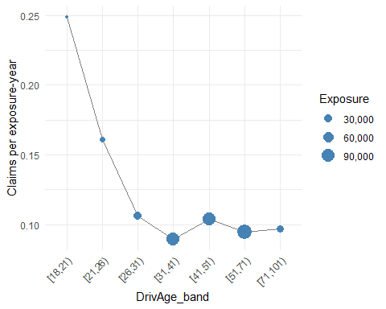
plot_freq(dat, VehAge_band)
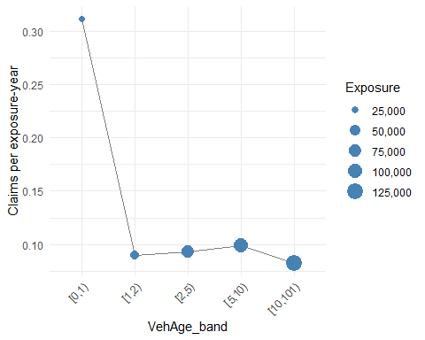
plot_freq(dat, BonusMalus_band)
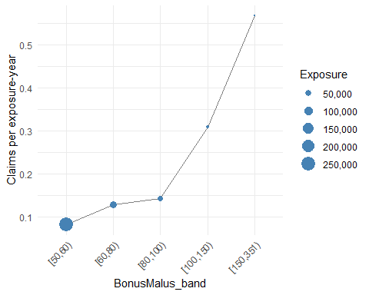
plot_freq(dat, Density_band)
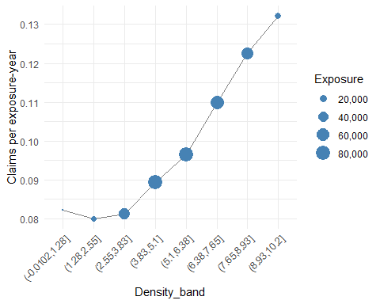
plot_freq(dat, Area)
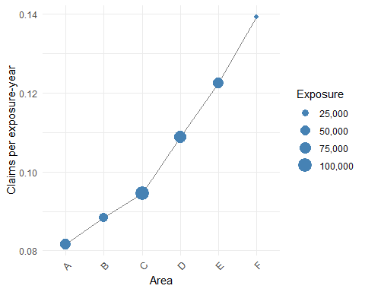
plot_freq(dat, VehPower)
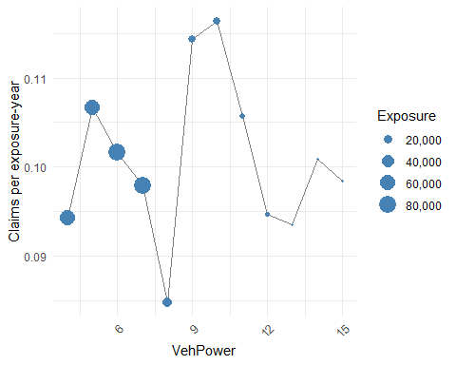
Answer. The { var } trick works inside aes() too, because ggplot2 uses the same tidy-evaluation machinery as dplyr. Encoding exposure in the point size stops you over-interpreting a frequency estimated from little data: the highest BonusMalus band and the oldest drivers have small exposure, so their frequencies are noisy. group = 1 is needed so that geom_line joins the points of a discrete x-axis into one line.

Task 7: Interactions
Two rating factors interact if the effect of one depends on the level of the other. In a frequency plot, that shows up as lines that are not parallel.
Extend freq_by() so that it takes two grouping variables, then plot frequency by DrivAge_band with one line per VehGas. Do the same for DrivAge_band and Area. Do you see an interaction?
freq_by2 <- function(data, var1, var2) {
data %>%
group_by({{ var1 }}, {{ var2 }}) %>%
summarise(exposure = sum(Exposure),
frequency = sum(ClaimNb) / sum(Exposure), .groups = "drop")
}
freq_by2(dat, DrivAge_band, VehGas) %>%
ggplot(aes(x = DrivAge_band, y = frequency, colour = VehGas, group = VehGas)) +
geom_line() + geom_point(aes(size = exposure)) +
scale_size_area(labels = label_comma()) +
labs(y = "Claims per exposure-year", size = "Exposure") +
theme_minimal()
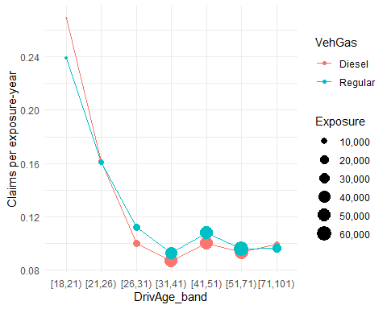
freq_by2(dat, DrivAge_band, Area) %>%
ggplot(aes(x = DrivAge_band, y = frequency, colour = Area, group = Area)) +
geom_line() + geom_point(aes(size = exposure)) +
scale_size_area(labels = label_comma()) +
labs(y = "Claims per exposure-year", size = "Exposure") +
theme_minimal()
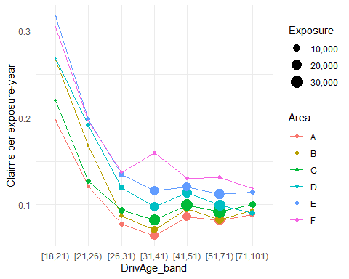
Answer. If the lines are roughly parallel (on whatever scale you are looking at) the two factors act additively and a model with main effects only is adequate; if they cross or fan out, an interaction term is needed. On the log scale, which is what a Poisson GLM works on, “parallel” means a constant ratio between the lines, so it can be worth plotting log(frequency) on the y-axis.
For VehGas the two lines are almost on top of each other and cross more than once: diesel is higher for 18–20 (0.27 vs 0.24), identical for 21–25 and slightly lower for 26–50. There is no evidence of an interaction worth modelling. For Area the picture is different: the age effect is much stronger in urban areas. Drivers aged 18–20 in area A have frequency 0.20, in area E 0.32; drivers aged 31–40 have 0.064 in A but 0.159 in F, so the ordering of areas is not even the same across age bands. A model with only main effects would miss this. Be cautious, though, where the exposure is small: area F and the 18–20 band each contain little data, and the F point at 31–40 may be partly noise.

Stretch: putting it together
Using only dplyr verbs, produce a table of the ten regions with the highest claim frequency among regions with at least 5,000 exposure-years, showing the number of policies, total exposure and frequency, sorted from highest to lowest.
dat %>%
group_by(Region) %>%
summarise(policies = n(), exposure = sum(Exposure),
frequency = sum(ClaimNb) / sum(Exposure), .groups = "drop") %>%
filter(exposure >= 5000) %>%
arrange(desc(frequency)) %>%
head(10)
# A tibble: 10 × 4
Region policies exposure frequency
<fct> <int> <dbl> <dbl>
1 R11 69791 30198. 0.132
2 R82 84752 45333. 0.111
3 R93 79315 35749. 0.109
4 R91 35805 14711. 0.103
5 R31 27285 11488. 0.102
6 R26 10492 5023. 0.102
7 R73 17141 7014. 0.0981
8 R53 42122 27753. 0.0974
9 R25 10893 6653. 0.0952
10 R72 31329 14316. 0.0942
Answer. Eight of the 22 regions fall below 5,000 exposure-years and are dropped; among the rest, R11 (Île-de-France, 0.132) is clearly the riskiest, followed by R82 and R93 at around 0.11. Without the exposure filter R94 (Corsica, 0.140 on 1,766 exposure-years) would top the table on much thinner evidence.

Part 3: Writing functions in R
These exercises practise writing functions from scratch. Each should be a single function definition followed by a line or two that calls it.
1. Write choose.members(n, c, p) that returns the number of ways to choose, from an organisation of $p$ people, an executive committee of $n$ named positions (president, treasurer, …) and $c$ at-large members of equal rank. For example, choose.members(2, 3, 10) should return 5040. Hint: choose() and factorial(); look at their help pages first.
choose.members <- function(n, c, p) {
named <- choose(p, n) * factorial(n) # ordered choice of n people, = p!/(p-n)!
at_large <- choose(p - n, c) # unordered choice from those left
named * at_large
}
choose.members(2, 3, 10)
[1] 5040
choose.members(3, 2, 8)
[1] 3360
Answer. The named positions are an ordered selection: choose $n$ people from $p$ and then arrange them in the $n$ roles, $\left({p \atop n}\right)n!=p!/(p−n)!$. The at-large members are an unordered selection from the $p−n$ people remaining, $\left({p−n \atop c}\right)$. Multiply the two. Check: $\left({10 \atop 2}\right)⋅2!⋅\left({8 \atop 3}\right)=45⋅2⋅56=5040$.
2. Write number.sequence(n) that returns the first $n$ terms of the sequence $2^{2}⋅3, 3^{2}⋅5, 4^{2}⋅7, 5^{2}⋅9, …$ so that number.sequence(4) returns 12 45 112 225.
number.sequence <- function(n) {
k <- 1:n
(k + 1)^2 * (2 * k + 1)
}
number.sequence(4)
[1] 12 45 112 225
Answer. The $k$-th term is $(k+1)^{2}(2k+1)$. Because R’s arithmetic is vectorised there is no need for a loop: build the vector 1:n and apply the formula to the whole thing.
3. Write is.even(n) which returns TRUE when $n$ is even and FALSE otherwise, then use it to write evens.in(v) which returns the even integers in a vector v. evens.in(c(3, 8, 11, 14, 20, 7)) should return 8 14 20.
is.even <- function(n) n %% 2 == 0
evens.in <- function(v) v[is.even(v)]
is.even(7)
[1] FALSE
evens.in(c(3, 8, 11, 14, 20, 7))
[1] 8 14 20
Answer. %% is the remainder operator. Because is.even is vectorised, is.even(v) returns a logical vector of the same length as v, which can be used directly to index v. No loop is needed.
4. The consecutive differences of $x_{1},x_{2},x_{3},…$ are $x_{2}−x_{1}, x_{3}−x_{2}, …$. Write consecutive.differences(v), first using vector indexing, then check your answer against the built-in diff().
consecutive.differences <- function(v) v[-1] - v[-length(v)]
v <- c(2, 5, 4, 10, 10, 3)
consecutive.differences(v)
[1] 3 -1 6 0 -7
diff(v)
[1] 3 -1 6 0 -7
Answer. v[-1] drops the first element and v[-length(v)] drops the last, giving two vectors of length $n−1$ that line up as $(x_{2},…,x_{n})$ and $(x_{1},…,x_{n−1})$. Their difference is the required sequence, and it matches diff(v).
5. Write histogram.for.simulated.uniform.data(n, num.bars) that simulates $n$ values from a Uniform(0, 1) distribution and plots a histogram with exactly num.bars bars. Hint: runif(), and read the breaks argument of hist() carefully: a single number is only a suggestion, but a vector of breakpoints is used exactly.
histogram.for.simulated.uniform.data <- function(n, num.bars) {
x <- runif(n)
hist(x, breaks = seq(0, 1, length.out = num.bars + 1),
main = paste0("n = ", n, ", ", num.bars, " bars"), xlab = "x")
}
set.seed(2)
histogram.for.simulated.uniform.data(100, 5)
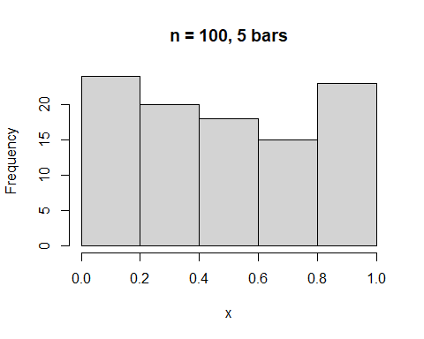
histogram.for.simulated.uniform.data(10000, 20)
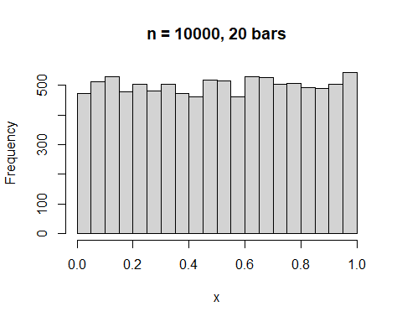
Answer. Passing breaks = 5 to hist() only suggests five bars; R then picks “pretty” breakpoints and may use more or fewer. Supplying the breakpoints explicitly as seq(0, 1, length.out = num.bars + 1) forces exactly num.bars equal-width bars on $[0,1]$. With small $n$ the bar heights vary a lot; with large $n$ they flatten out towards the uniform density, an illustration of the law of large numbers.

